**IE4717 Web Application Design - Project Report**

**Design project group number**: F31-DG01

**Team members**: Lu Jingjun, Ding Shaobo

**Project Title**: Lawrence Electronics Shops Online

**Summary of Project**:

We aim to design and develop a website which sells electronic devices. In this website, all the products will be the latest and good electronic devices and users will be able to browse different categories of products and the detailed information of them. In addition, every user will need to sign in / sign up with an account to start purchasing. The account will be linked to an email. Besides, when customers find the products they like they can add it to their shopping cart to save it for later. Lastly, they can checkout with various methods and an order confirmation email will be sent to the email address linked to the customers’ account.

1. Application Requirements and Specifications: high level requirements

* The online electronics store will allow users to browse and search electronics products, view product details, add to carts and make payments. The users will need to sign up for the first time and login to add to cart or start purchasing. Profile information can be updated after login.

2. Functional Requirements and Specifications: functional pages

* Home page
* Login page
* Sign up page
* Shopping cart page
* Product listing page
* Product detail page
* Payment page
* Profile settings page

3. Design of the web application

* Site Map :

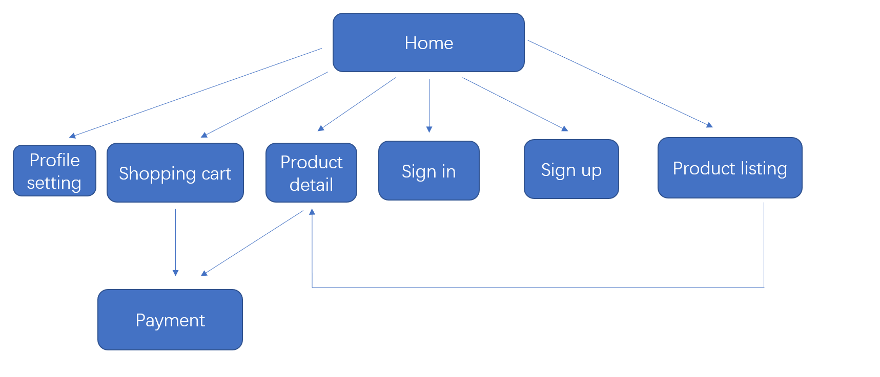

* Story Board:

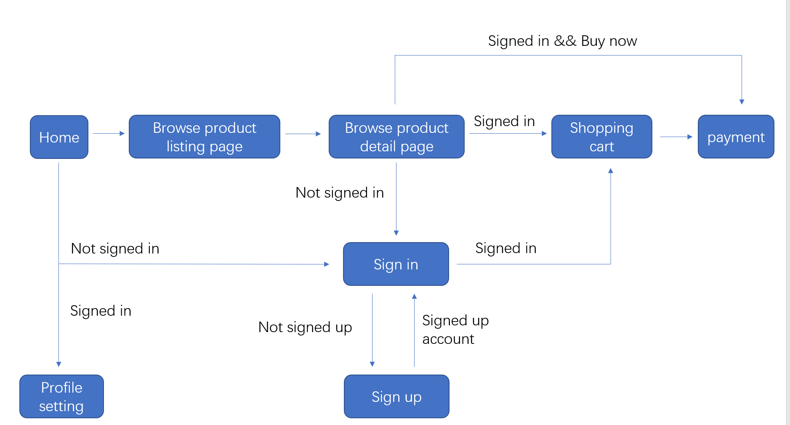

* Wireframe:

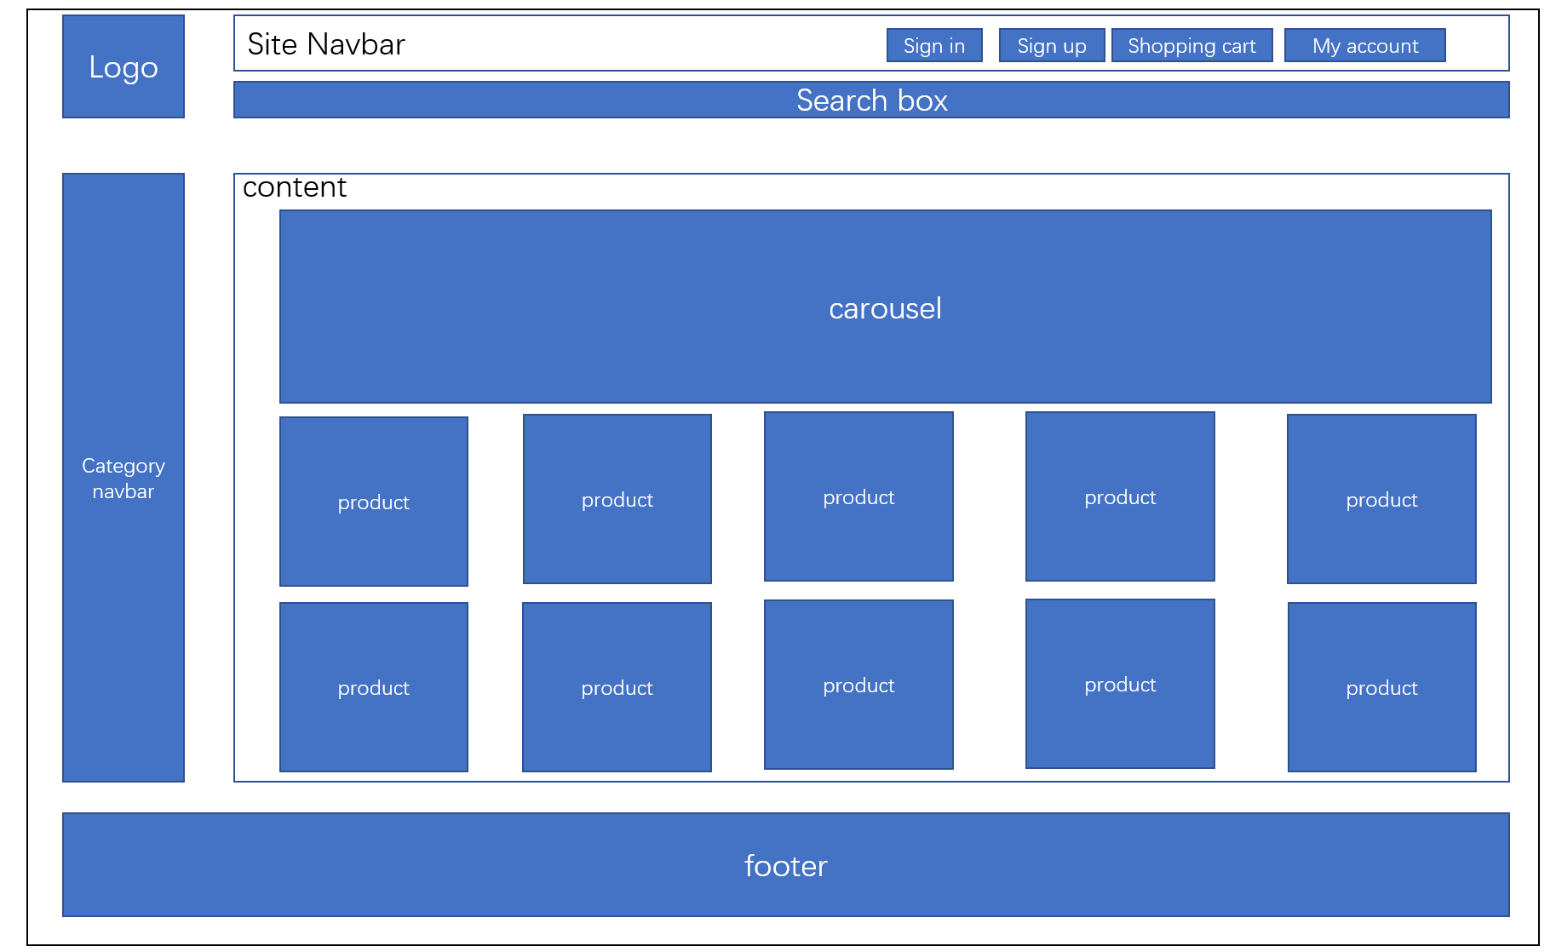

* Database

User

id

address

username

email

password

Product:

id

name

price

category

stock

img_url

Product in cart:

User_id

Product_id

Quantity

status/ or delete record

Order:

id

User_id

Order_number (random generate)

Status

Total_price

Order_item:

Order_id

Product_id

Quantity